*No Humans Allowed*

**Synopsis:**

*No Humans Allowed* creates a community of mechatronic personalities that reside in the “gated” WaveCave community. The personalities are xenophobic: reacting to outsiders via paralysis or violence. When the presence of a human is detected, the community breaks down and no longer functions harmoniously. The result is a hostile space that outsiders are not able to enter without being either attacked or shunned by the society residing within.

**Project Description:**

Each of the six mechatronic sound sculptures (personalities) are constructed from extruded aluminum, acrylic, ultrasonic rangefinders, solenoids, DC motors and LED’s. The personalities are either hanging from the grid or resting on the floor depending on their size and construction. The ultrasonic rangefinders allow each personality to detect the presence of gallery viewers who will affect their behavior. When no outside presence is detected, all members of the community are alive, active, and productive. The presence of a human or ‘other’ disrupts the community. If the outsider gets too close to any specific sculpture, the personality will either become paralyzed by hate and fear (turn off) or will attempt to “violently” deter the intruder (loud, abrupt, a-rhythmic noises). Either way, the personality will be so preoccupied by the presence of the ‘other’ it will no longer contribute to the community as a whole, disrupting the harmony of society.

No Humans Allowed hopes to shine light on the danger of xenophobic ‘other’ thinking that is becoming more and more common in the UK with Brexit and the United States with the election of Trump.

**Gallery Diagram:**

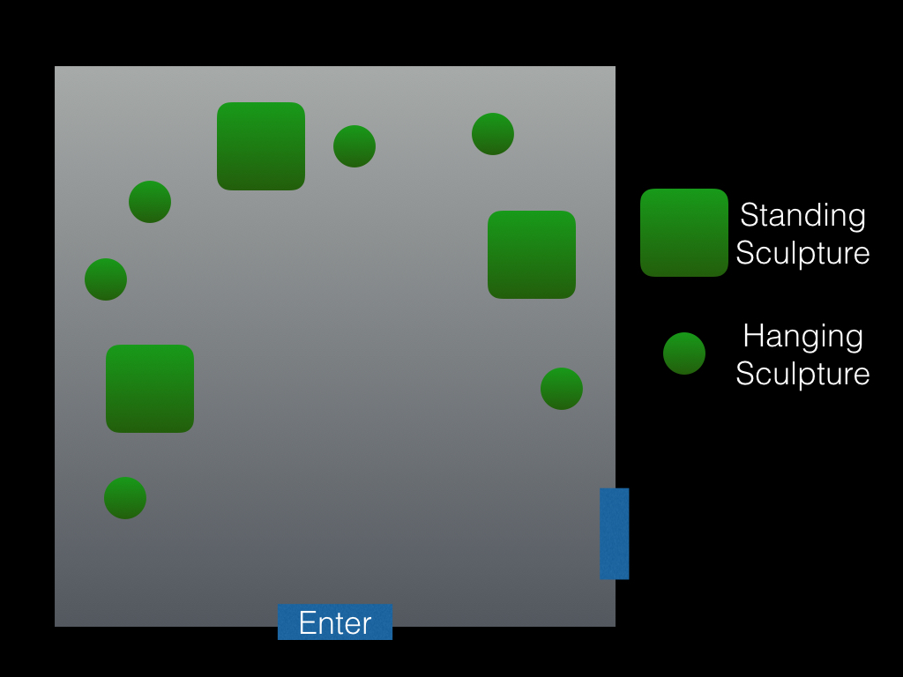

**System Diagram:**

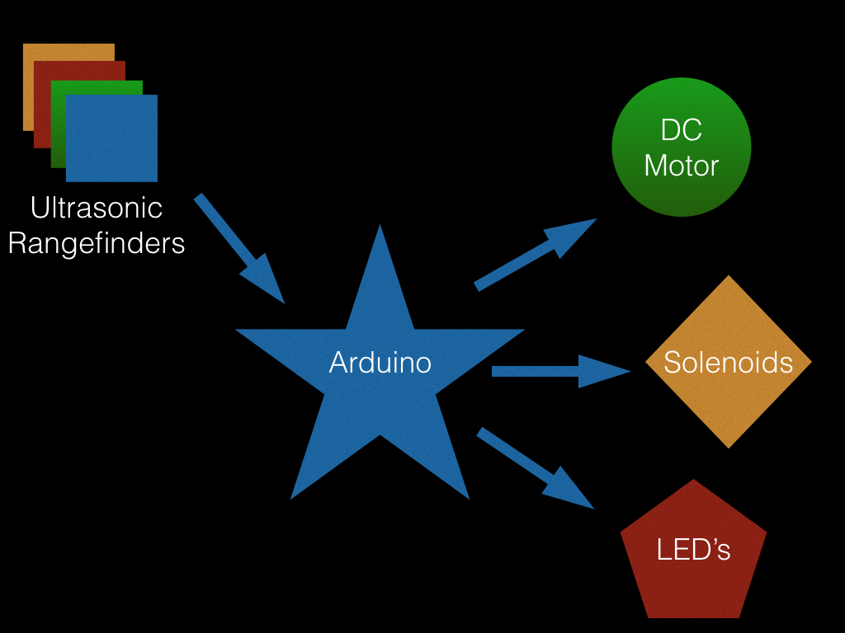

**Pertinent links:**

Most of my work can be found on either my YouTube channel or my personal website.

YouTube :<https://www.youtube.com/channel/UCNDFycD86Sos2ckxruuLb2Q>

Personal Website : <http://bitdeph.com/>

I have included two pictures of one of the Mechatronic Sculptures in a halfway finished state: the other personalities will exhibit similar aesthetic qualities.

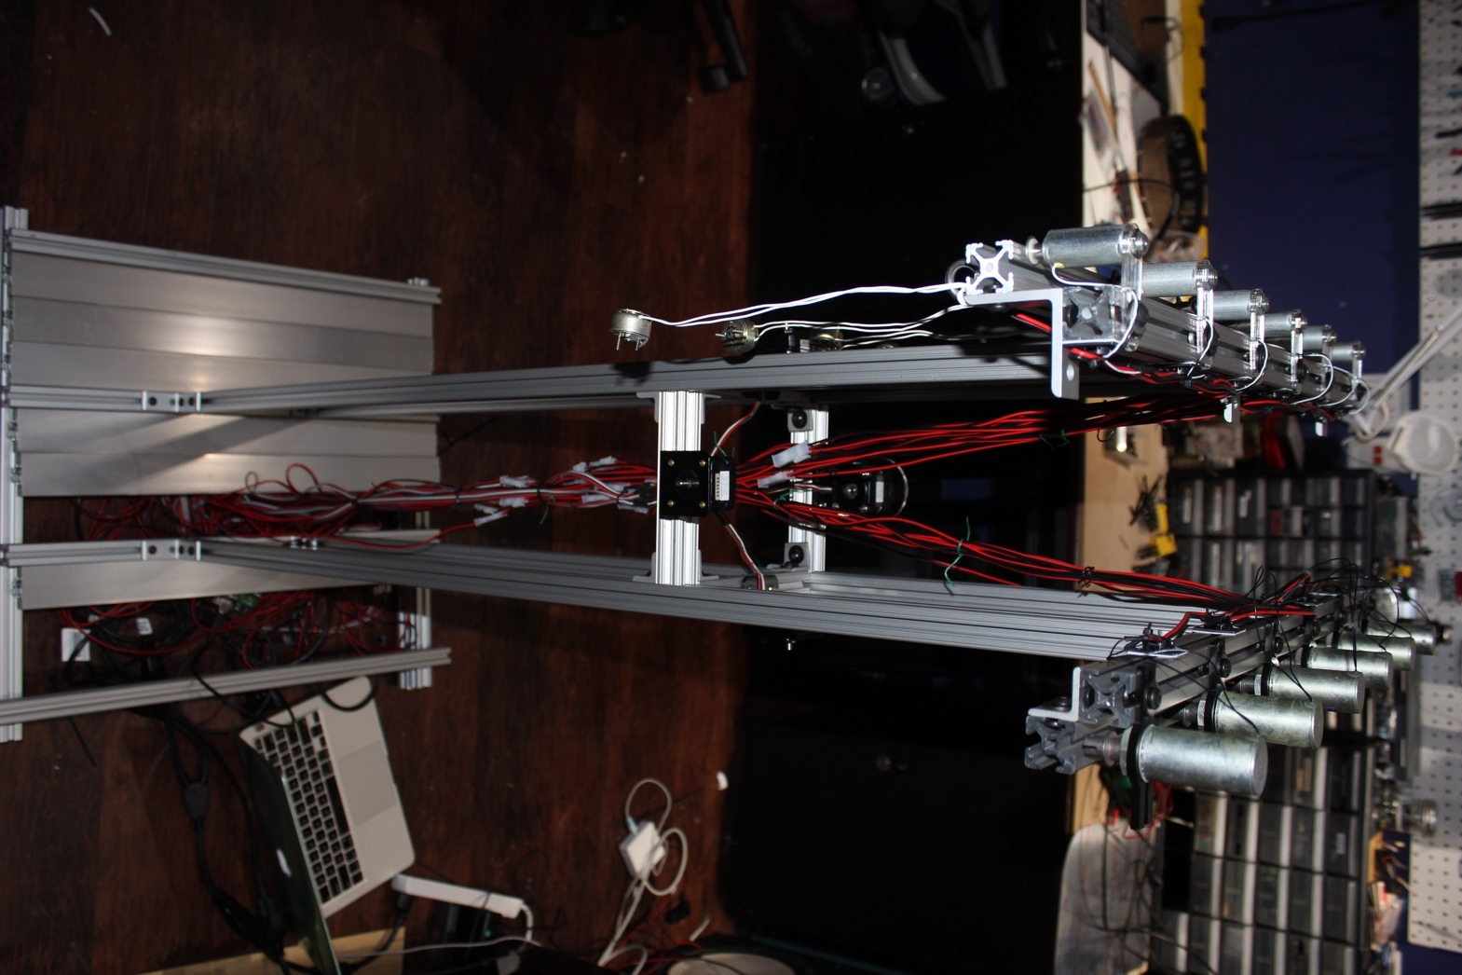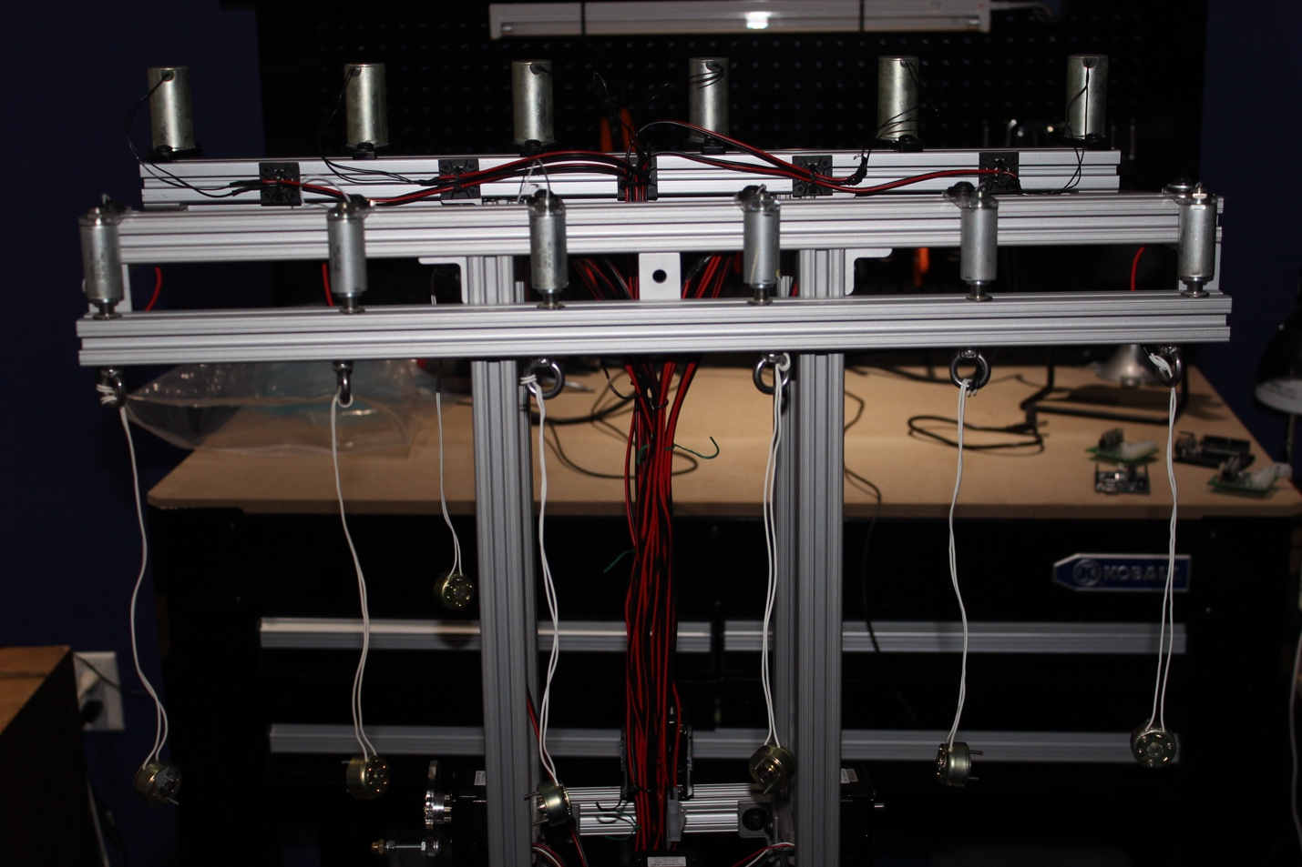

**Bio:**

Nathan Villicaña-Shaw creates installations that complicate, simplify, and question our social/personal relationship with electronics. Nathan is a MFA candidate and BFA alum from the MTIID (Music Technology: Intelligence and Interaction Design) department at CalArts; where his research focuses on challenging human-circuit interaction modalities. Nathan spends most of his time creating interactive installation art, building expressive mechatronic systems, composing, hardware hacking, and developing software for the art and corporate spheres.